This is my cat. Her name is Zhuzha. She has been living with me for four years. I love Zhuzha very much. And I have two more cats. The second is called Marfa. She has been living with us for five years. Marfa is Zhuzhu’s mum.They love each other too.They play together.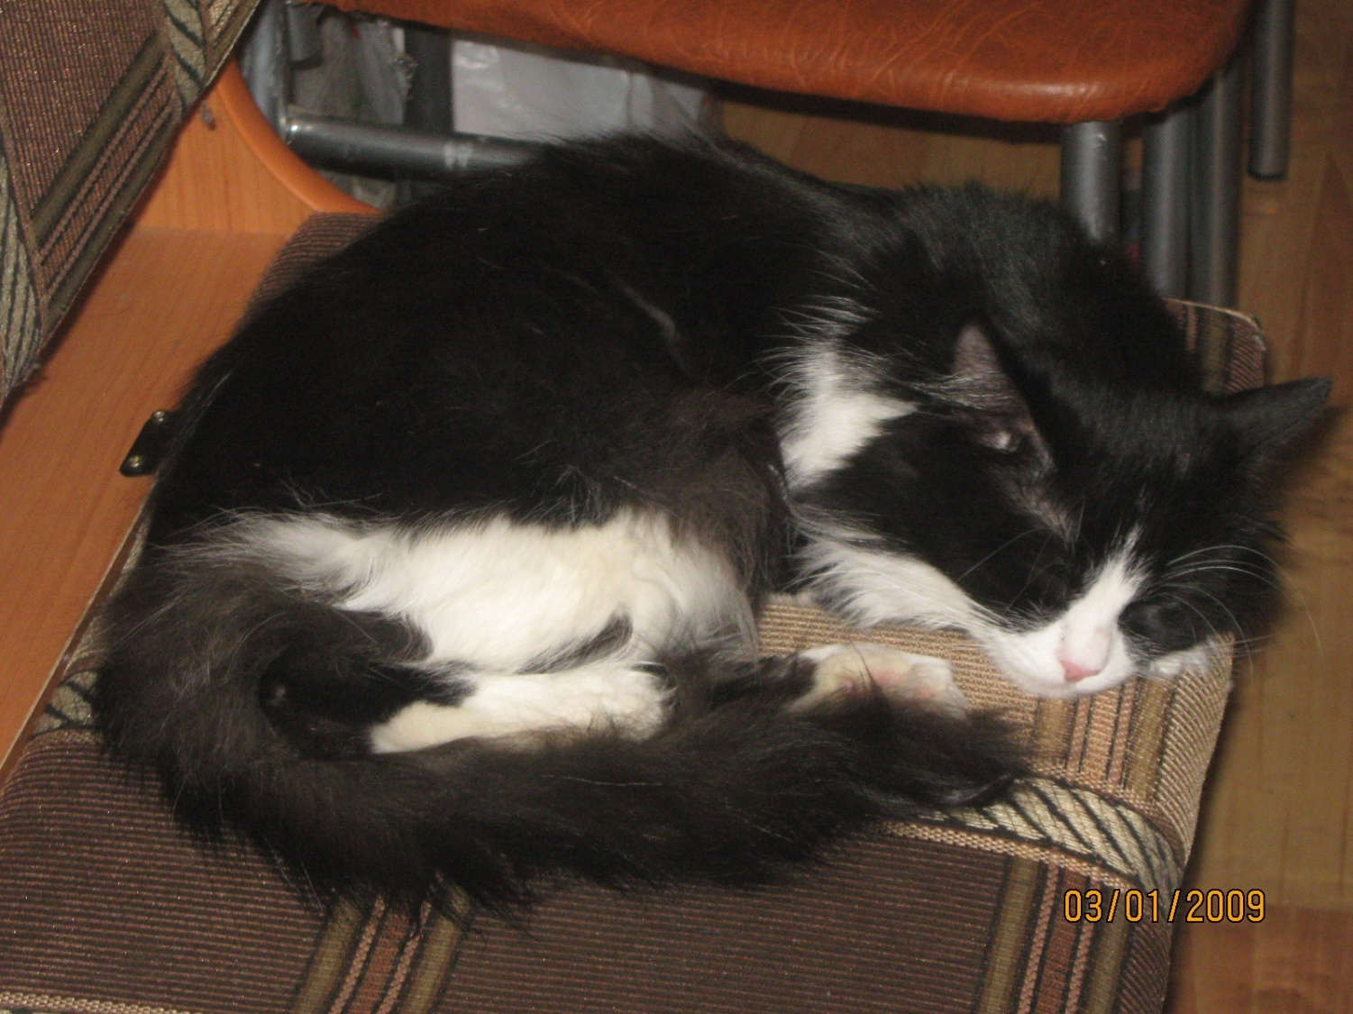 Zhuzha

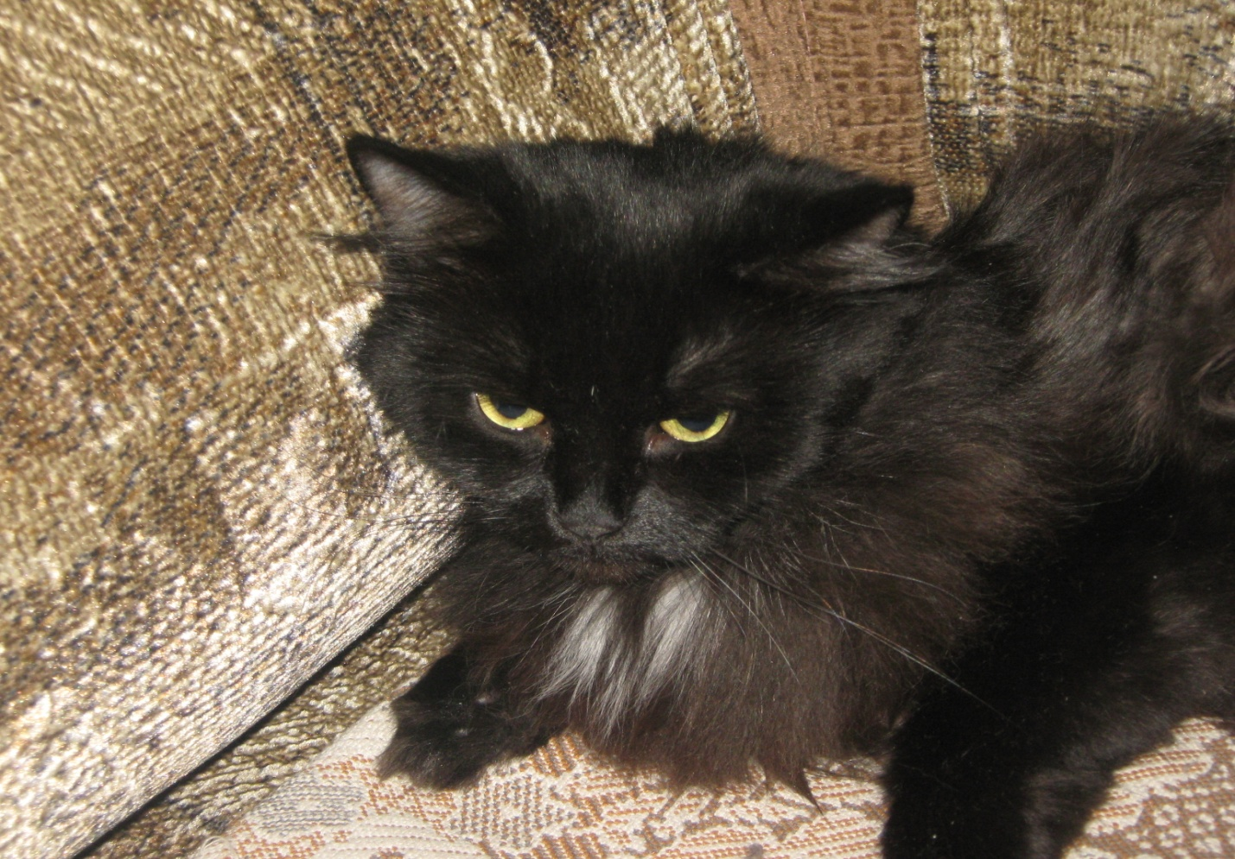
Marfa

